
ELLA LANGLEY TAKES DANDELION ON THE ROAD WITH
HEADLINING ARENA TOUR KICKING OFF MAY 7

TICKETS ON SALE FRIDAY FEBRUARY 6

SOPHOMORE ALBUM DANDELION SET FOR RELEASE APRIL 10

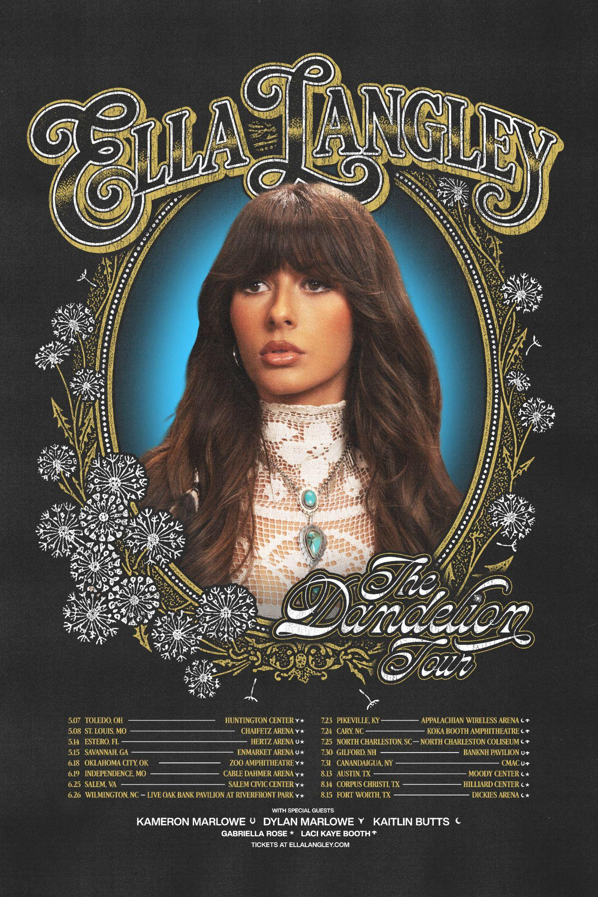
Download Tour Poster

Today, Ella Langley has announced ‘The Dandelion Tour’, a new run of headline shows coming to arenas across the US this year. Kicking off May 7 in Toledo, OH, the 16-date run includes stops in St. Louis, Oklahoma City, Austin, and more before wrapping in Fort Worth on August 15. Joining Ella on tour as support across various dates is Kameron Marlowe, Dylan Marlowe, Kaitlin Butts, Gabriella Rose, and Laci Kaye Booth.

Tickets to ‘The Dandelion Tour’ will be available via presale beginning Thursday, February 5 at 10am local time. Fans can register to access presale tickets on ellalangley.com. General on-sale begins on Friday, February 6 at 10am local time. Ella has also launched a new merch bundle today featuring an all new tour tee and Dandelion vinyl.

In celebration of the announcement, Ella is currently featured on the cover of Pollstar and shared her excitement about bringing her new music to the stage.

The tour news follows closely behind the reveal of Ella’s forthcoming album, Dandelion, set for global release on April 10. Executive produced by Ella alongside Miranda Lambert and Ben West, Dandelion stands as her most personal body of work to date. Rooted in growth, self-reflection, and lived-in storytelling, the album is designed to feel easy and effortless — balancing raw honesty with feel-good moments that invite listeners to both lean in and let go. It includes her latest single, the title track “Dandelion,” as well as her massive hit song “Choosin’ Texas,” which catapulted to #1 on the Billboard Streaming Songs chart this week and became just the fourth country song by a lead woman to top the chart in its 13-year history. The song also reached the #1 spot on both the U.S. Spotify Chart and the Apply Music U.S. Songs Chart on Friday, and will officially impact Pop Radio this week.

Ella's rise has largely been fueled by her relentless touring over the years. With every headline tour selling out and a touring résumé that includes opening for many of country music’s most established acts, she’s emerged as a commanding live performer and an arena artist in her own right.

Also on the schedule for 2026 are her previously-announced dates supporting Eric Church’s ‘Free The Machine Tour’, additional dates on Morgan Wallen’s ‘Still The Problem Tour’, and several festival appearances. Full routing for ‘The Dandelion Tour’ is below, and all Ella Langley tour dates are available at ellalangley.com.

Dandelion Tour Dates
Date City Venue/Event
5/7/2026 Toledo, OH Huntington Center (+,&)
5/8/2026 St. Louis, MO Chaifetz Arena (+,&)
5/14/2026 Estero, FL Hertz Arena (@, &)
5/15/2026 Savannah, GA Enmarket Arena (@, &)
6/18/2026 Oklahoma City, OK Zoo Amphitheatre (+,&)
6/19/2026 Independence, MO Cable Dahmer Arena (+,&)
6/25/2026 Salem, VA Salem Civic Center (+,&)
6/26/2026 Wilmington, NC Live Oak Bank Pavilion at Riverfront Park (+,&)
7/23/2026 Pikeville, KY Appalachian Wireless Arena (#, %)
7/24/2026 Cary, NC Koka Booth Amphitheatre (#, %)
7/25/2026 North Charleston, SC North Charleston Coliseum (#, %)
7/30/2026 Gilford, NH BankNH Pavilion (@, %)
7/31/2026 Canandaigua, NY CMAC (@, %)
8/13/2026 Austin, TX Moody Center (#, &)
8/14/2026 Corpus Christi, TX Hilliard Center (#, &)
8/15/2026 Fort Worth, TX Dickies Arena (#, &)

Support Acts
@ Kameron Marlowe
+ Dylan Marlowe
# Kaitlin Butts
& Gabriella Rose
% Laci Kaye Booth


Dandelion Artwork Shot by Caylee Robillard
Download Album Art

Follow Ella Langley
Website | Instagram | TikTok | YouTube | Facebook

###

