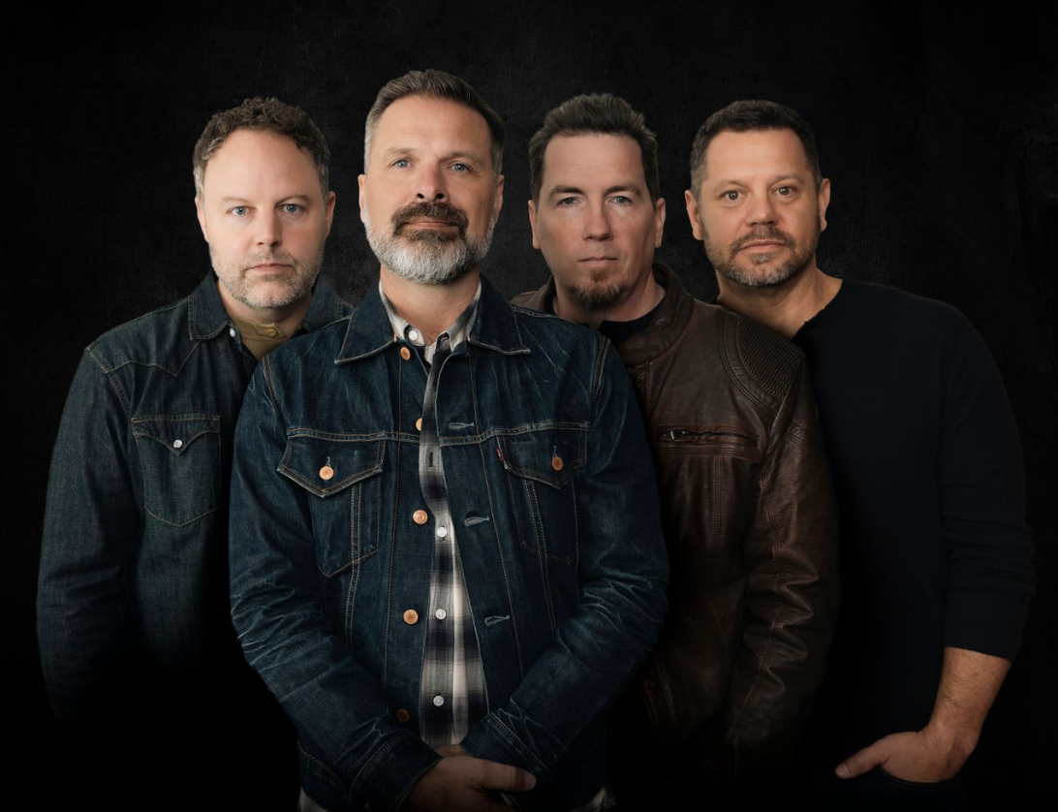

ERA-DEFINING BAND THIRD DAY ANNOUNCES 30TH ANNIVERSARY TOUR FOR 2026
MAC POWELL, MARK LEE, DAVID CARR AND TAI ANDERSON REUNITE FOR A LIMITED TIME TO HEADLINE 30-CITY ARENA TOUR CELEBRATING THEIR LEGENDARY CATALOG OF HITS
Also Featuring GRAMMY Award-winning artist Zach Williams, Tickets for Historic Live Event Go on Sale Friday, June 27 at 10 a.m. Local Time at www.ThirdDay.com and www.AwakeningFoundation.com

Atlanta, GA… June 18, 2025 - One of the most iconic bands in Christian music history, the four-time GRAMMY Award-winning and multi-platinum rock band THIRD DAY is thrilled to announce its upcoming 30th anniversary tour today. Set to hit arenas across the U.S. in spring 2026, the THIRD DAY 30th Anniversary Tour will span 30 once-in-a-lifetime shows with a finale in the band’s hometown Atlanta market.

For the first time in 11 years, the hall-of-fame band's original four members, Mac Powell, Mark Lee, David Carr and Tai Anderson will reunite on stage for an unforgettable victory lap. Fans will experience an electrifying, can't-miss live event featuring a bucket-list of crowd favorites, pulling from THIRD DAY's impressive 31 No. 1 singles across 14 albums.

Tickets go on sale Friday, June 27 at 10 a.m. local time at www.ThirdDay.com and www.AwakeningFoundation.com. Fueled by THIRD DAY'S 2018 farewell tour making history by selling out in 12 minutes, there is enormous anticipation for the anniversary tour ticket sale date. The tour is being produced by the Awakening Foundation. Full list of 2026 dates and markets below.

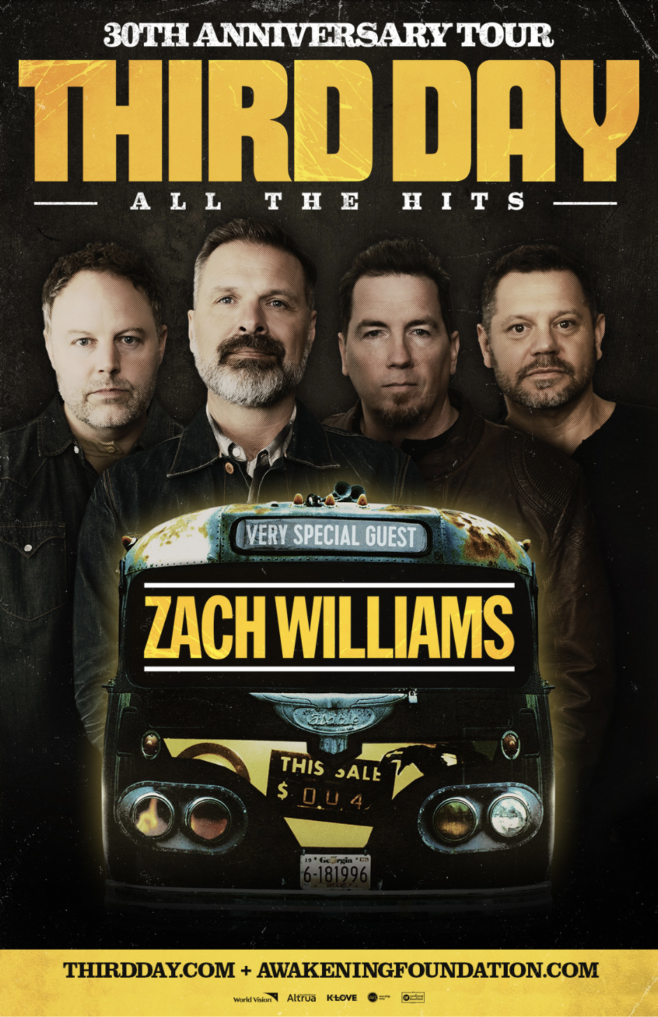

Founding members Mac Powell and Mark Lee recently shared their excitement on getting back on tour with Third Day, with Powell saying, "I’ve been getting asked the question for many years, 'when is Third Day going to do a tour again' and I’ve always said… One day soon I hope!" He continues, "I’m so excited that we finally get the chance to play music together again on stage and give our fans what they’ve been waiting for."
Lee adds, " Third Day has always been, first and foremost, a live band. The best way to celebrate 30 years is to get back together for a tour. I can’t wait to get back out on the road with these guys and put on a big show for our fans."
Kicking off March 19, 2026, in Jacksonville, Fl., at the Vystar Veterans Memorial Arena, the industry-pioneering band will perform to arena-sized audiences in venues including the Kia Forum in Los Angeles, Ca., Nashville's Bridgestone Arena and wrapping this reunion tour for the first and last time in THIRD DAY's hometown Atlanta area, at the Gas South Arena on May 10, 2026.
Acclaimed GRAMMY-Award winning artist Zach Williams is also slated to appear on THIRD DAY's 30th Anniversary Tour. Known for massive hits including "Chain Breaker" and his "There Was Jesus" duet with Dolly Parton, Williams will bring his in-demand soulful and gritty faith-based rock to the show.

“Celebrating 30 years of THIRD DAY is a true honor, and bringing Mac, Mark, David & Tai back to the stage is something fans have been waiting for,” said Dan Fife, CEO of Awakening Events. “Adding Zach Williams as a very special guest makes this tour even more powerful. This is going to be a once-in-a-lifetime night of live music and celebration for all generations to experience.”

This monumental THIRD DAY 30th Anniversary Tour event celebrates the immense impact of the band's unparalleled 30 years since their self-titled, major-label debut in 1996 on Reunion Records.
About THIRD DAY:
Founded in Atlanta, Ga., in 1991, by Mac Powell and Mark Lee, THIRD DAY became one of the most influential live bands in Contemporary Christian Music over its nearly 30-year career. The band sold over 10 million albums, achieved 31 No.1 singles, and released 14 studio albums. Their accolades include 4 GRAMMY Awards, 24 Dove Awards, an American Music Award, induction into the Georgia Music Hall of Fame and multiple ASCAP honors, including the prestigious Vanguard Award for songwriting. THIRD DAY also made notable media appearances on The Tonight Show with Jay Leno, The Late Late Show with Craig Ferguson, CBS' 60 Minutes, ABC's Nightline, USA Today, The New York Times, and even graced the cover of Billboard Magazine, which hailed them as "one of the best rock bands, period."

About AWAKENING FOUNDATION: The Awakening Foundation exists to share the message of hope and resources with individuals and families in local and international communities by bringing together artists, fans, and like-minded organizations through live events and missional endeavors to serve and empower those in need. Awakening Foundation events are powered by Awakening Events. Consistently ranked among the top promoters in America and reaching as high as No. 3 in the world in total tickets sold, we are a leader in the live faith-based entertainment industry. Be sure to find out more at AwakeningFoundation.com.
THIRD DAY 30TH ANNIVERSARY TOUR DATES:
3/19/26 Jacksonville, FL - VyStar Veterans Memorial Arena
3/20/26 Estero, FL - Hertz Arena
3/21/26 Pensacola, FL - Pensacola Bay Center
3/22/26 Orlando, FL - Kia Center
3/26/26 Austin, TX - Moody Center
3/27/26 Grand Prairie, TX (Dallas) - Texas Trust CU Theatre at Grand Prairie
3/28/26 Sugar Land, TX (Houston) - Smart Financial Centre at Sugar Land
3/29/26 Tulsa, OK - BOK Center
4/2/26 Toledo, OH - Huntington Center
4/3/26 Youngstown, OH - Covelli Centre
4/4/26 Grand Rapids, MI - Van Andel Arena
4/9/26 Minneapolis, MN - Target Center
4/10/26 Chicago, IL - Credit Union 1 Arena
4/11/26 St. Louis, MO - Chaifetz Arena
4/12/26 Nashville, TN - Bridgestone Arena
4/16/26 Henderson, NV - Lee’s Family Forum
4/17/26 Stateline, NV - Tahoe Blue Event Center
4/18/26 Portland, OR - Veterans Memorial Coliseum
4/19/26 Kent, WA (Seattle) - accesso ShoWare Center
4/23/26 Sacramento, CA - Golden 1 Center
4/24/26 Inglewood, CA (Los Angeles) - Kia Forum
4/25/26 San Diego, CA - Pechanga Arena San Diego
4/26/26 Glendale, AZ (Phoenix) - Desert Diamond Arena
4/29/26 Kansas City, MO - T-Mobile Center
4/30/26 Fishers, IN (Indianapolis) - Fishers Event Center
5/1/26 Birmingham, AL - Legacy Arena at BJCC
5/7/26 Dayton, OH - Wright State University Nutter Center
5/8/26 Fairfax, VA - EagleBank Arena
5/9/26 Charlotte, NC - Bojangles' Coliseum
5/10/26 Duluth, GA (Atlanta) - Gas South Arena
###

