FOR IMMEDIATE RELEASE
CONTACT: Nancy Milton
618-791-8007
nancy@insightrocks.com
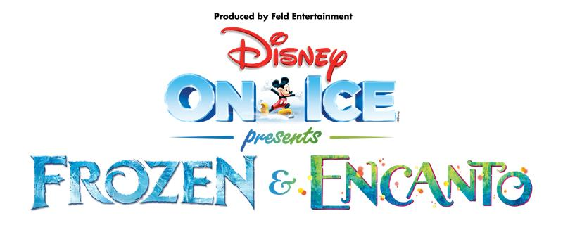

EMBRACE THE MAGIC OF FAMILY IN AN ALL-NEW ADVENTURE THAT WILL SPARK YOUR IMAGINATION IN DISNEY ON ICE PRESENTS FROZEN & ENCANTO!
The only place to see the Madrigal family live!
Tickets On Pre-Sale April 25, 2023 in St. Louis
(St. Louis, MO – April 25, 2023) – For the first time, Disney On Ice invites families to step inside the magical adventures of Walt Disney Animation Studios’ Frozen, the #1 Animated feature of all time, and Disney Animation’s Encanto, the 2022 Academy Award®, BAFTA®, and Golden Globe® Award winner for Best Animated Feature, as they come to life like never before. This adventure on ice transports fans into two of the most popular Disney films as audiences can sing-along to their favorite songs while embracing world-class ice skating, aerial acrobatics and more when it visits their hometown at Chaifetz Arena from September 22-24, 2023!

Audiences will see Anna, Elsa, Mirabel, and the Madrigal family live, as well as fan favorites Mickey Mouse, Minnie Mouse, Donald, Goofy, and many more.

Narrating the captivating story of Frozen is Olaf, the lovable snowman who likes warm hugs and all things summer. Astounding ice-skating transports families to Arendelle to be a part of Anna’s adventure to find Elsa, whose icy powers unleashed an eternal winter. Kristoff and Sven take fans along as they encounter wintry conditions in a race to bring back summer.

After a very Frozen adventure, audiences will journey to a vibrant town in the mountains of Colombia where they will meet the Madrigals, an extraordinary family who live in a magical casita in a wondrous, charmed place called an Encanto.

Mirabel tells the tale of her amazing family and her journey to save the casita, her enchanted family home, alongside her sisters: Isabela, whose perfection radiates with her ability to make plants grow and flowers bloom with every step, and Luisa, with the gift of super strength that she uses to help her village move buildings and reroute rivers.

For the first time live, fans can witness Tia Pepa, who can control the weather with her emotions; her husband Felix; their daughter Dolores, with her gift to hear; and Bruno, the mysterious and misunderstood Madrigal family member whose visions foretold the future.

In the end, audiences will learn that everyone has their own gifts, magical or not, and being true to yourself and loving those around you is what makes you special. YOU are the magic!

Enhance your Disney On Ice show ticket with a preshow Character Experience, “Family Fun with Elsa and Mirabel”, that includes crafting and interactive time with Elsa and Mirabel. Bring your personal device for photo opportunities.

Please note: Each guest (ages 2 and up) must have both a Character Experience ticket and a Disney On Ice show ticket to attend; children must be accompanied by an adult.

WHERE: Chaifetz Arena – 1 South Compton Avenue, St. Louis, MO. 63103
WHEN: Friday, September 22 7:00 PM
Saturday, September 23 11:00 AM, 3:00 PM & 7:00 PM
Sunday, September 24 11:00 AM, 3:00 PM & 7:00 PM

TICKETS: Family friendly ticket pricing available – tickets can be purchased online at Ticketmaster.com or in-person at the venue Box Office.
*Ticket pricing is subject to change based on market demand.

Disney On Ice Preferred Customers can purchase advance tickets starting today, April 25, 2023, to get the best seats available before tickets go on-sale to the public on May 2, 2023. Fans can still sign up to become a Disney On Ice Preferred Customer and get exclusive access to the pre-sale offer code.

MEDIA PHOTOS/VIDEO: Members of the media can visit here for photos and video.

For more info about Disney On Ice, follow Disney On Ice social media channels: Facebook, Twitter & Instagram. Subscribe to the Disney On Ice YouTube Channel at www.youtube.com/DisneyOnIce

###
About Feld Entertainment®
Feld Entertainment® is the worldwide leader in producing and presenting live touring family entertainment experiences that bring people together and uplift the human spirit. Properties include Ringling Bros. and Barnum & Bailey®, Monster Jam®, Monster Energy Supercross, Disney On Ice, Marvel Universe LIVE!, and Jurassic World Live Tour. Across the brand portfolio, Feld Entertainment has entertained millions of families in more than 75 countries and on six continents. Visit feldentertainment.com for more information.

